DAVA ASSIGNMENT

**PART 2**

**AY2021/2022 Apr Semester**

**DECLARATION**

I declare that I am the originator of this work and that all other original sources used in this work have been appropriately acknowledged.

I understand that plagiarism is the act of taking and using the whole or any part of another person’s work and presenting it as my own without proper acknowledgement.

I also understand that plagiarism is an academic offence and that disciplinary action will be taken for plagiarism.”

|  |  |
| --- | --- |
| √ | I Agree (Please Tick ✓) |

|  |  |
| --- | --- |
| **My Information** | |
| Name (as in matriculation card) | Chan Jun Qi, Julius |
| Admin Number | 2082753A |
| Class (E.g. Group 1) | Group 1 |

# DAVA – It’s Data Prep Time

1. Derive New Columns

a) Show the steps taken to prepare new column (field) called *length_of_stay.*

I used the Math Formula node to find the length of stay and configured it by appending the column called length of stay and used the math formula expression “$stays in weekend nights$ + $stays in weeknights$”.

**Configuration**

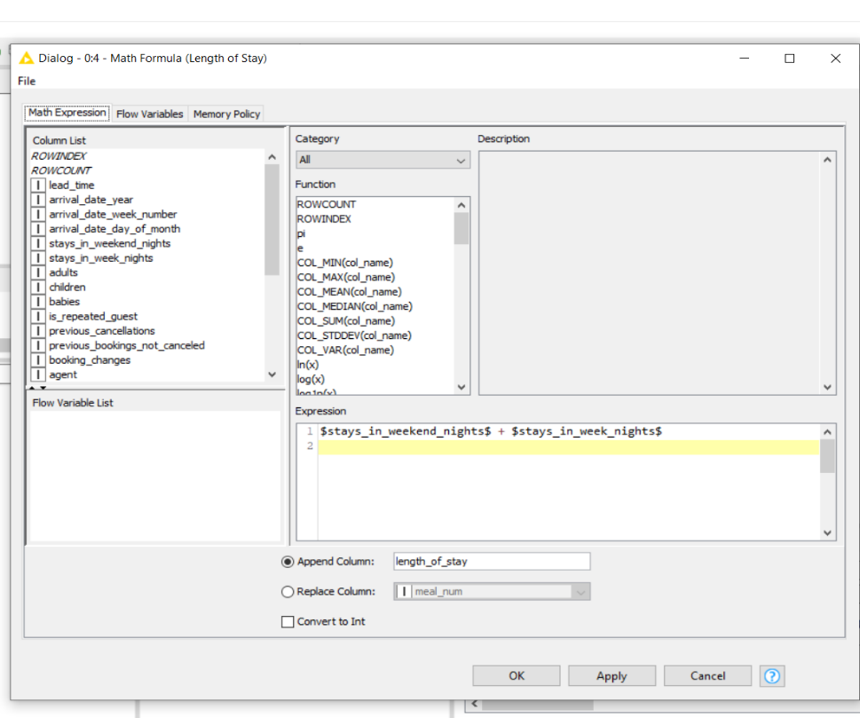

**Results**

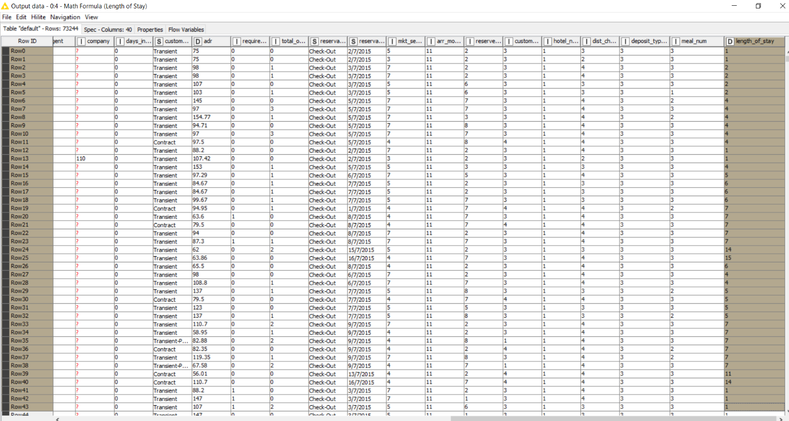

1. Show the steps taken to prepare new column (field) called *kids.*

To find the number of kids, I added another Math Formula node, which I configured by appending the column called Kids and used the math formula phrase "$children$ + $babies$."

**Configuration**

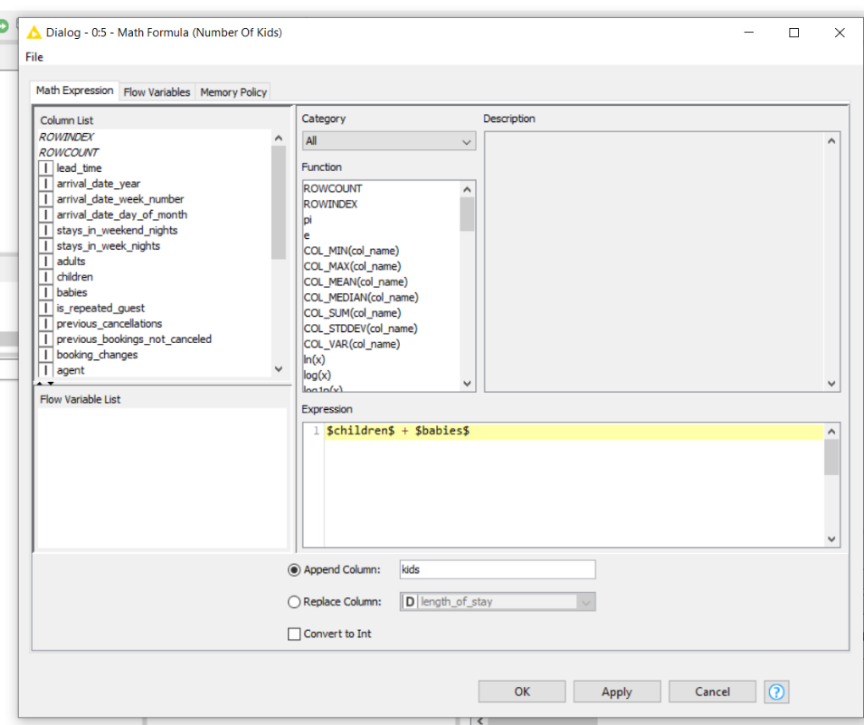

**Results**

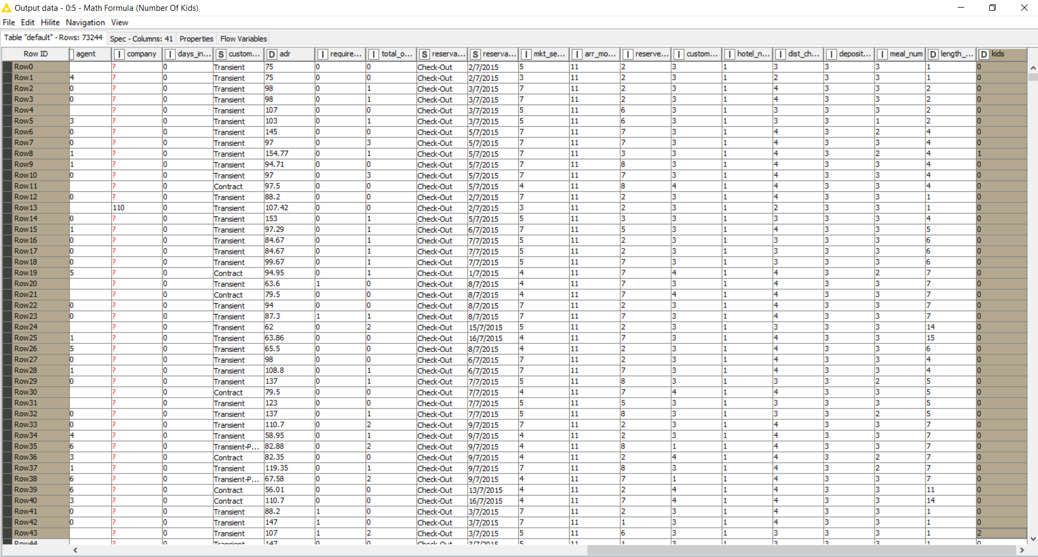

1. Show the steps taken to prepare new column (field) called *guest_type.*

I ran the Rule Engine node by appending a new column named guest_type and used the following expression of

$adults$ = 1 AND $kids$ = 0 => "single"

$adults$ = 2 AND $kids$ = 0 => "couple"

$adults$ > 2 AND $kids$ = 0 => "family-adult"

$kids$ > 0 => "family-children"

TRUE => “others”

**Configuration**

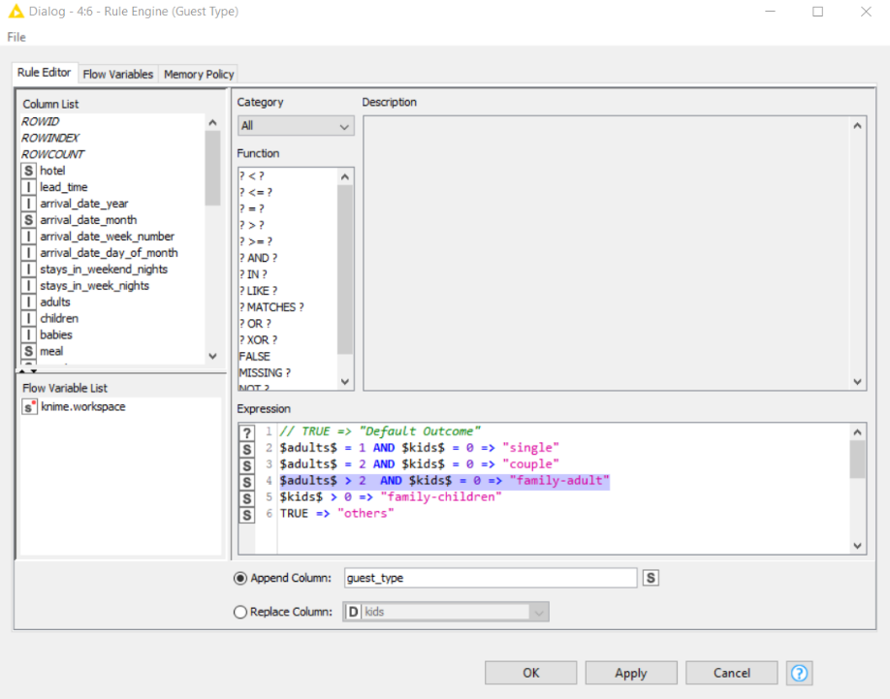

**Results**

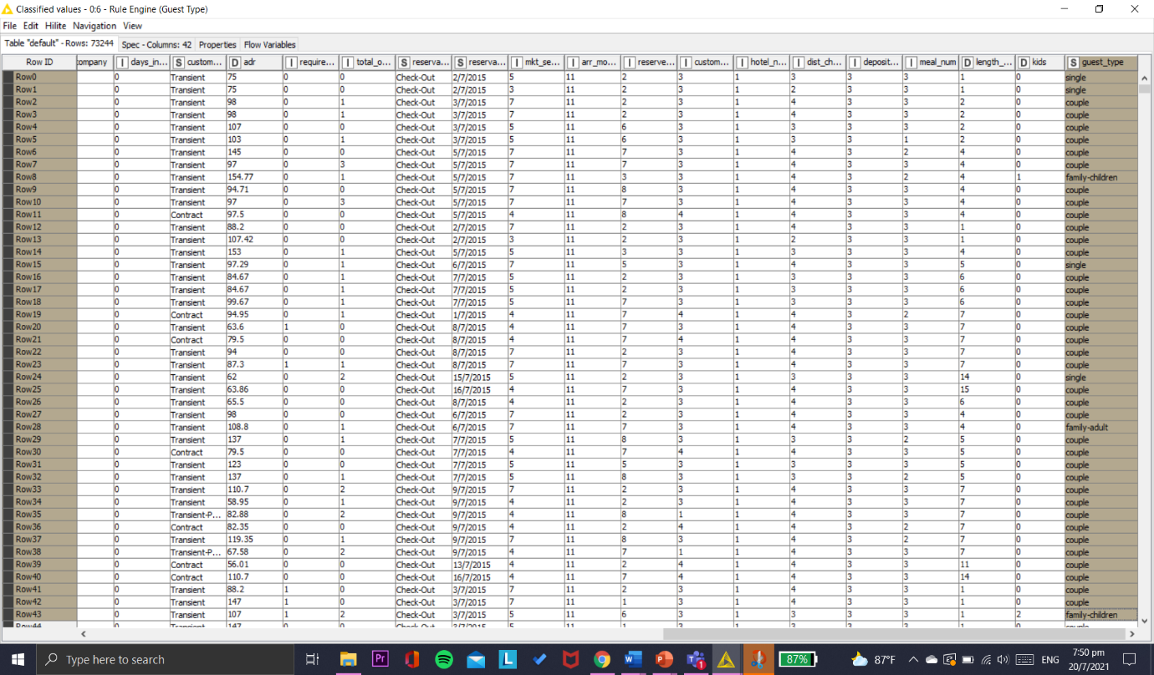

1. Show the steps taken to prepare new column (field) called *guest_type_num.*

I added and ran another Rule Engine node to categorize the number of guest types per guest type by appending a new column called guest_type_num and used the following expression of

$guest_type$ LIKE "single*" => "1"

$guest_type$ LIKE "couple*" => "2"

$guest_type$ LIKE "family-adult*" => "3"

$guest_type$ LIKE "family-children*" => "4"

TRUE => “others”

**Configuration**

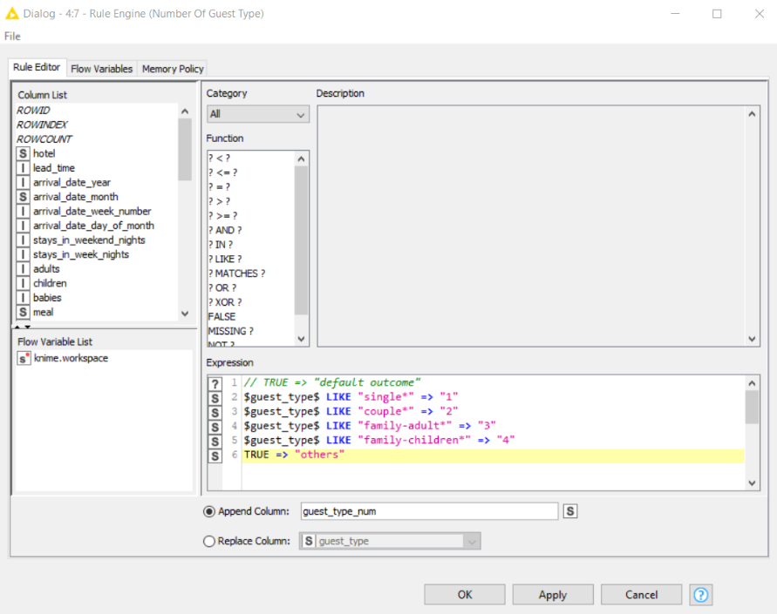

**Results**

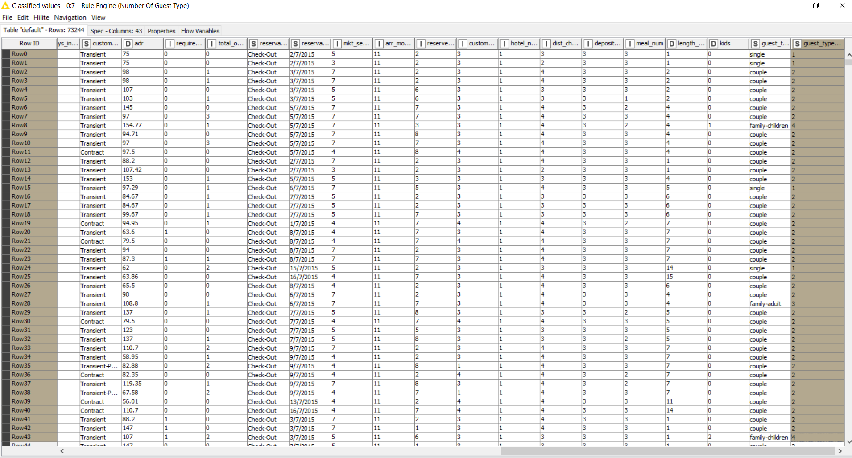

2. Data Cleaning

a) Show the steps taken to convert the columns to string type.

Continuing from the rule engine node, I added and used the Number To String (PMML) node, I did the configuration and transformed the columns agent and company to string types, as they represent IDS.

**Before**

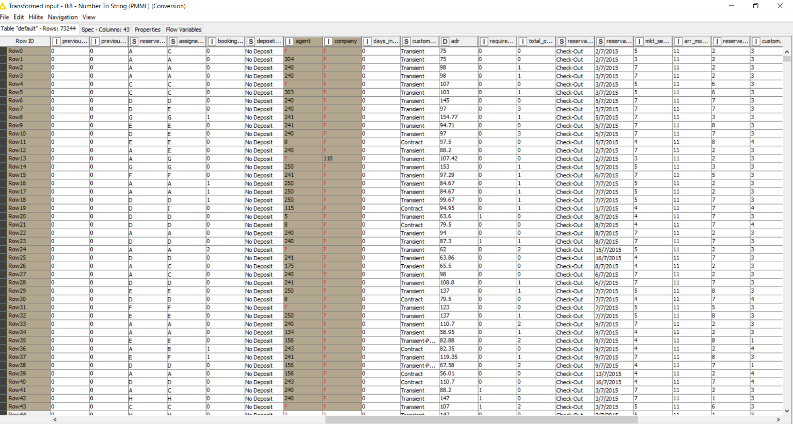

**Configuration**

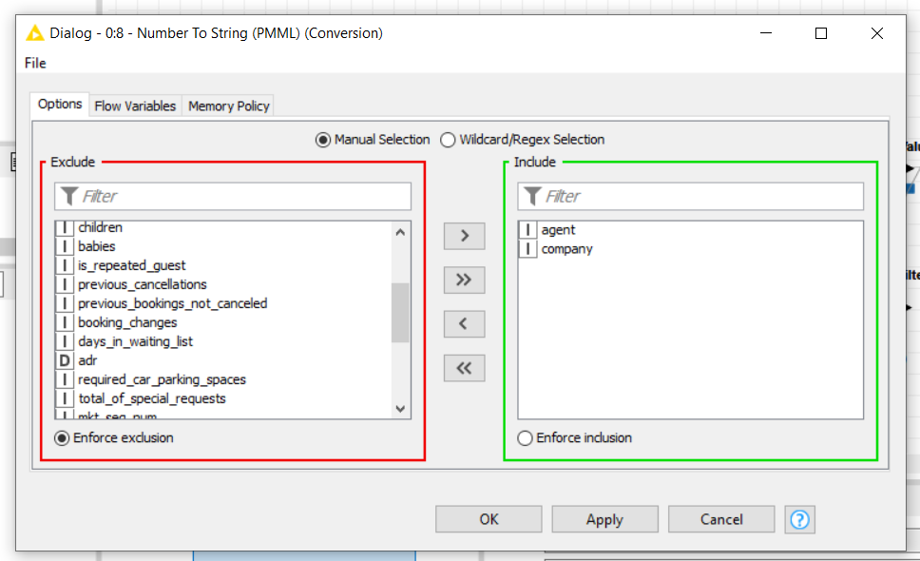

**Results**

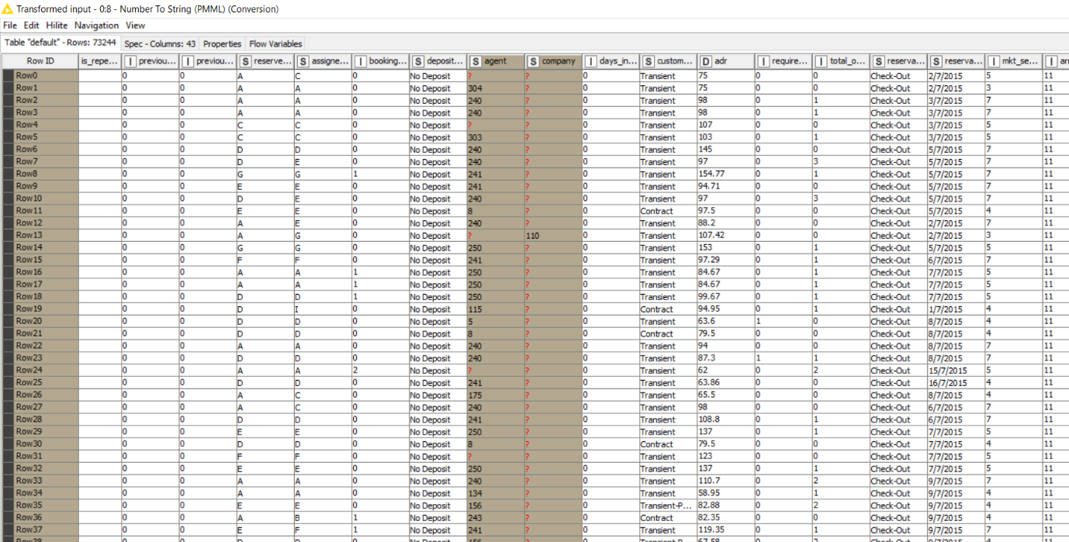

b) Show the steps taken to handle missing values in the data and to justify why you chose the method for each case.

I added the statistics node downstream from Number to String Node to identify the fields with missing values. I went to the statistics table to look for missing numeric values, then went to the nominal histogram table to look for missing values for nominal rows. When I opened the file, I discovered that 4 fields had missing values.

**To check for missing values**

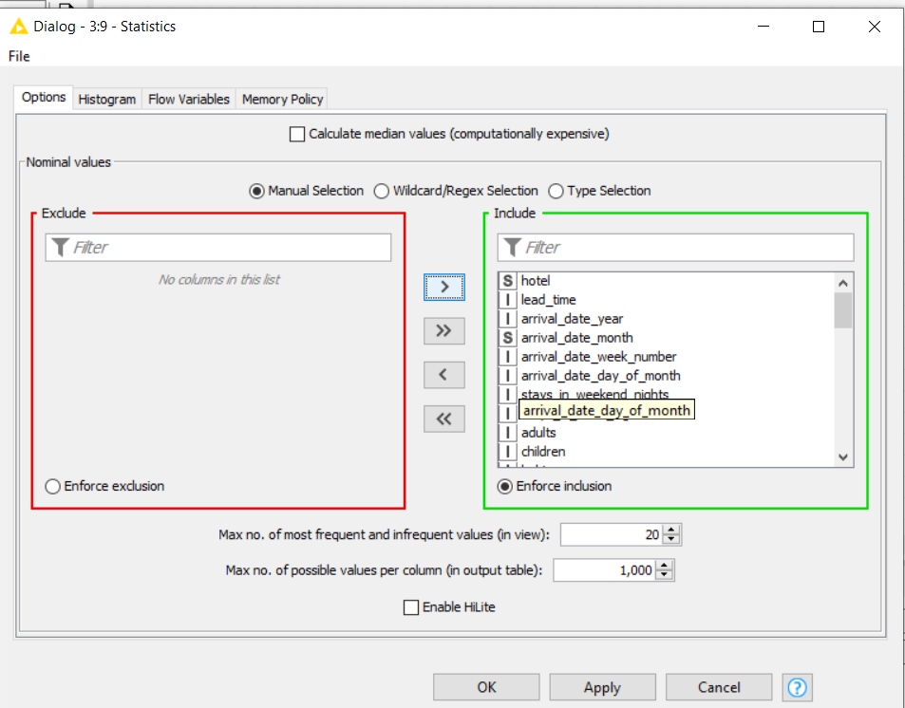

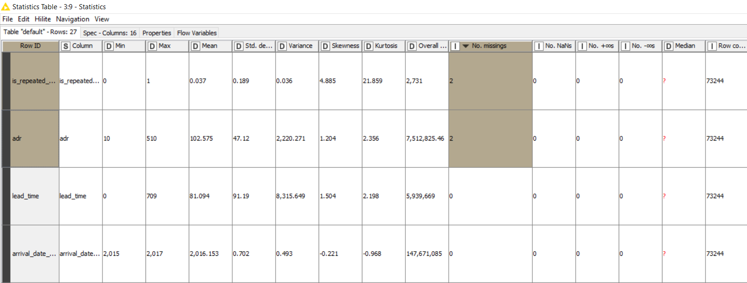

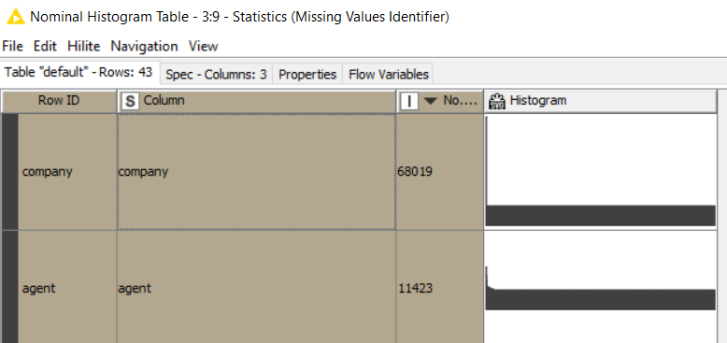

I added the Missing Value node from the Number to String node and configured each field with missing data separately. I used the ‘Fix Value’ and replace it with NULL as an imputation method for the fields 'agent' and 'company' because it a string type that represents IDs which means its a unique attribute and most of the columns consists of missing values.

The rows “is_repeated_guest” and “adr” are the same two rows with missing values in the two respective column, I use the ‘Remove Row' as an imputation approach.

Apart from the missing values in the two columns, there are also missing values in 'company' resulting in a large number of missing values in the two rows, therefore it's best to remove it.

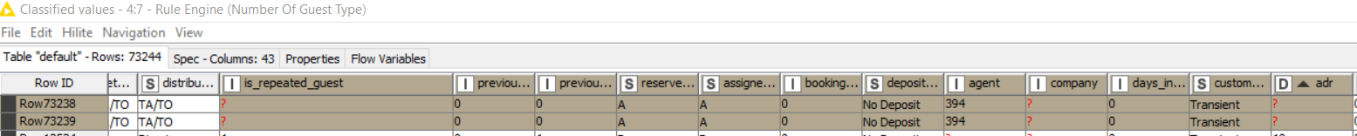

**Configuration**

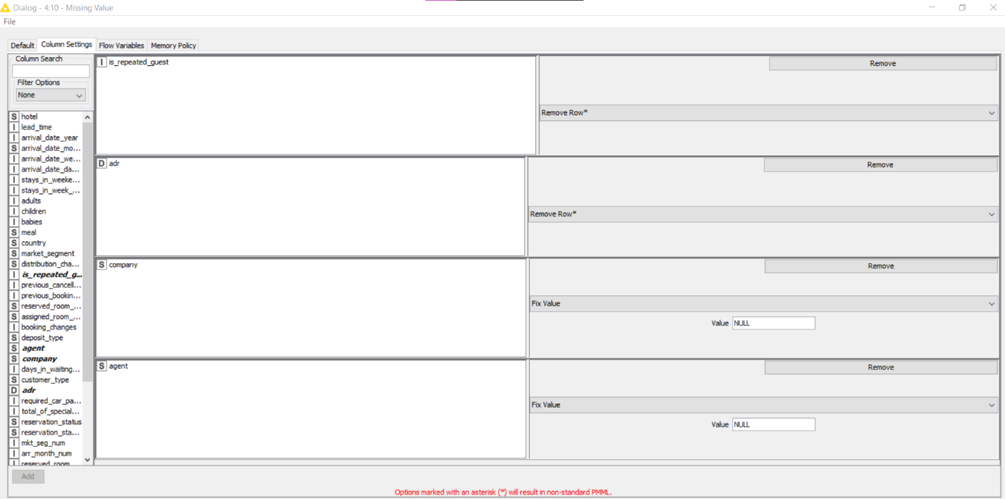

I added the Statistics node from the Missing Value node and included all the missing fields to make sure there was no more missing data.

**Results**

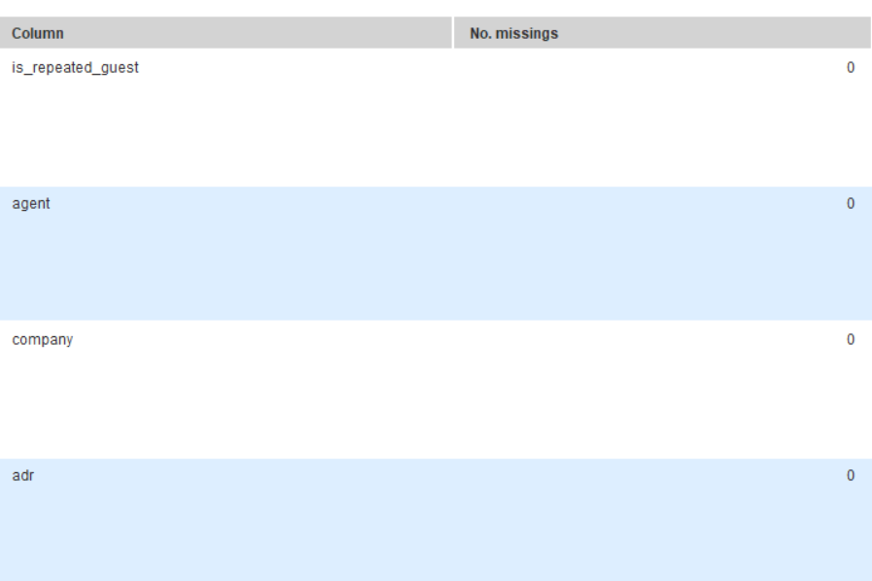

c) Show the steps taken to remove some columns.

I added the Column Filter node from the Missing Value node and did a configuration to remove the following fields.

• arrival_date_year

• stay_in_weekend_nights

• stay_in_week_nights

• adults

• children

• babies

• previous_cancellations

• previous_bookings_not_canceled

• assigned_room_type

• booking_changes

• day_in_waiting_list

• reservation_status

• reservation_status_date

• kids

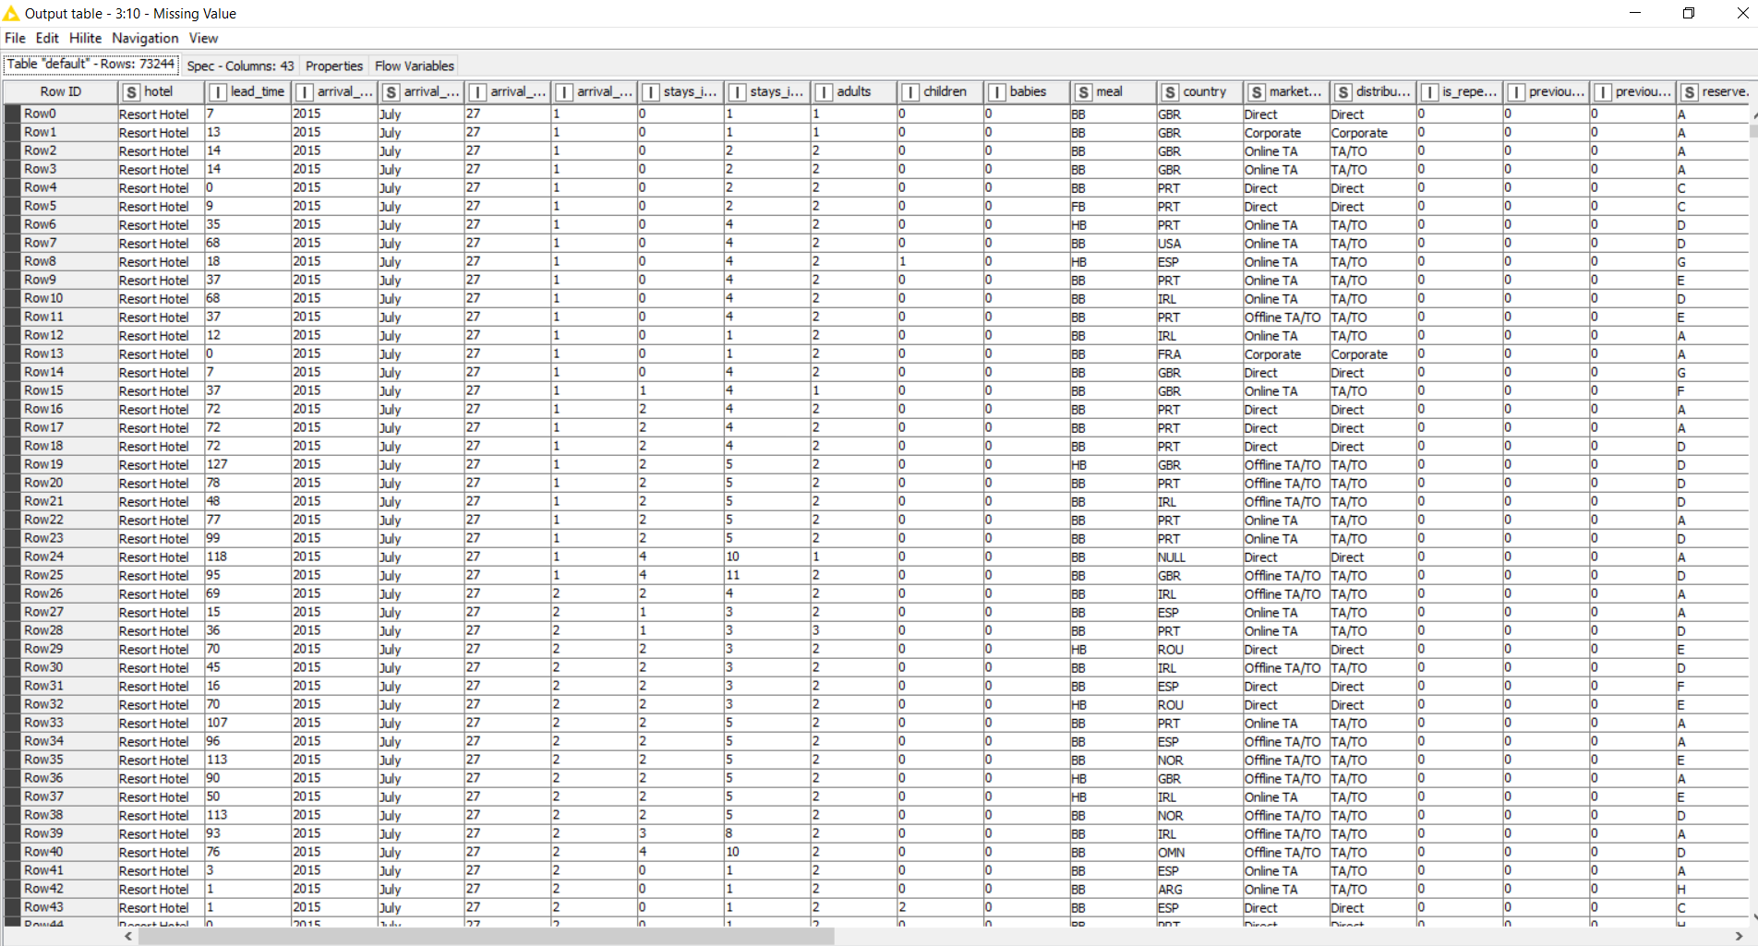**Before (43 Columns)**

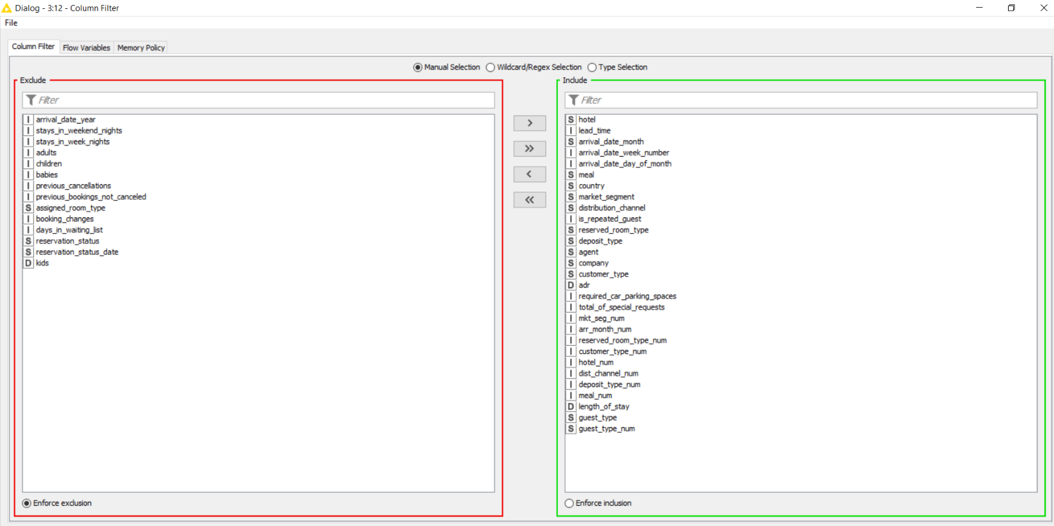**Configuration**

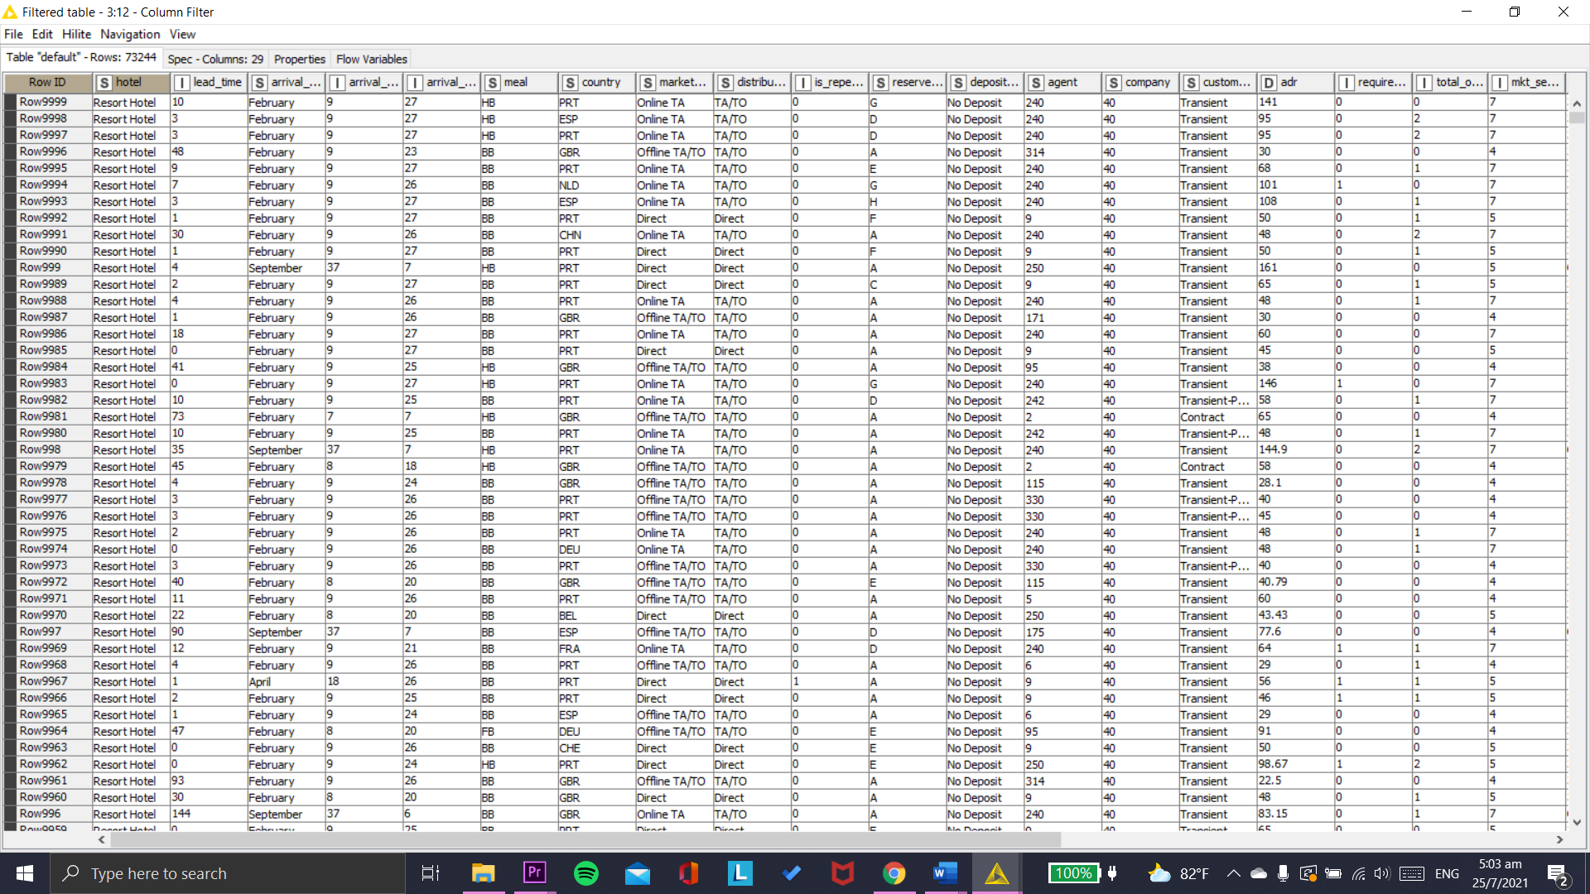**Results (29 Columns)**

d) Show the steps taken to handle other opportunity for improving the quality of the data.

To sort the arrival date week number, I used the sorter node from the column filter. The arrival date week number is not in ascending order, making the data difficult to understand.

**Configuration**

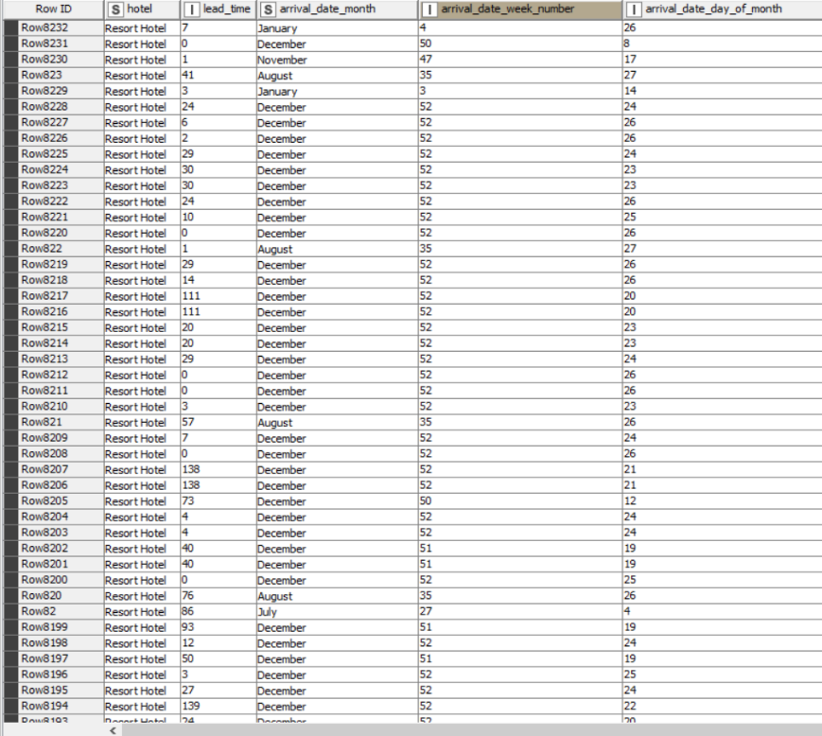

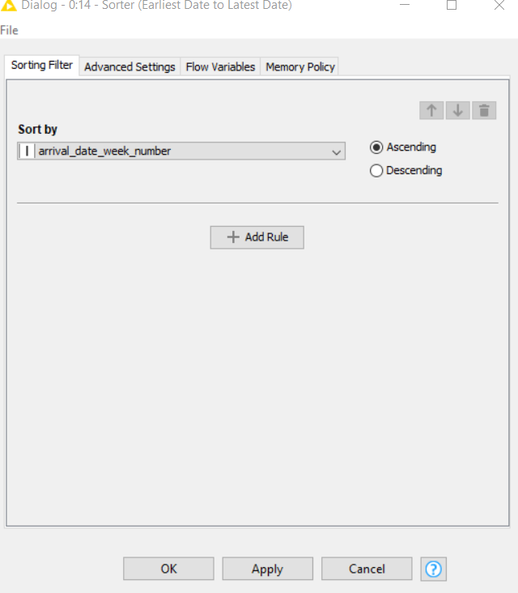

**Results**

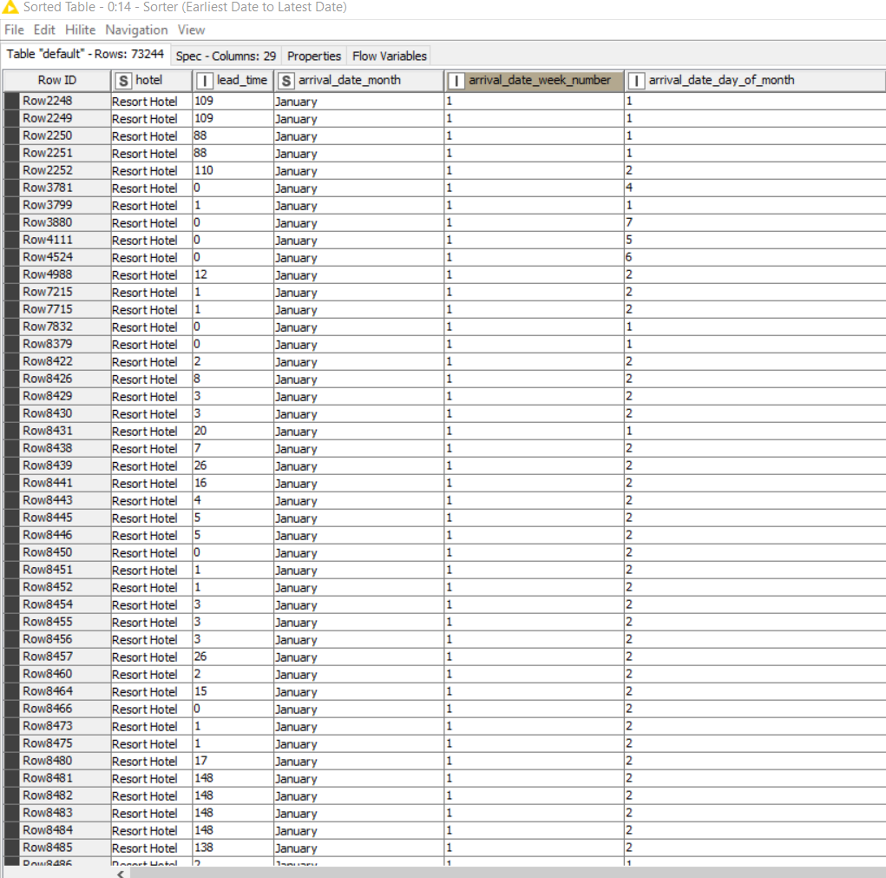

Length_of_stay column type has been converted to interger as its based on the calculation on interger type of number of stays in weekend day and night thus it doesn’t contain any decimal points.

**Before**

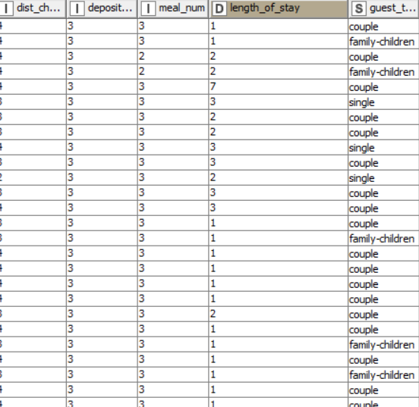

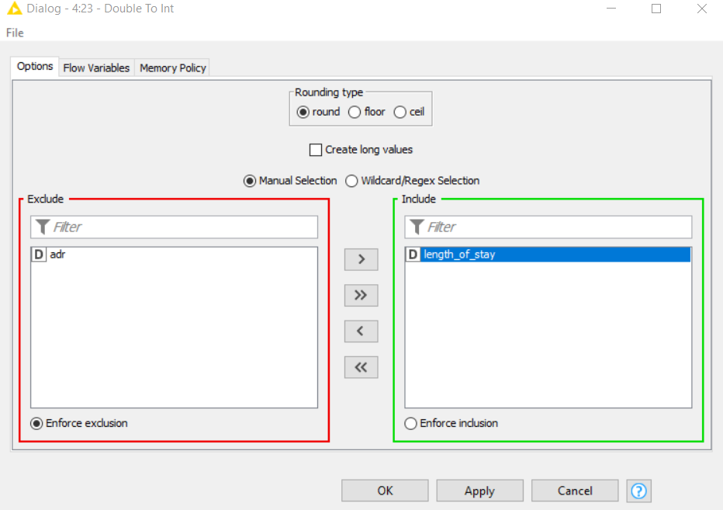

**Results**

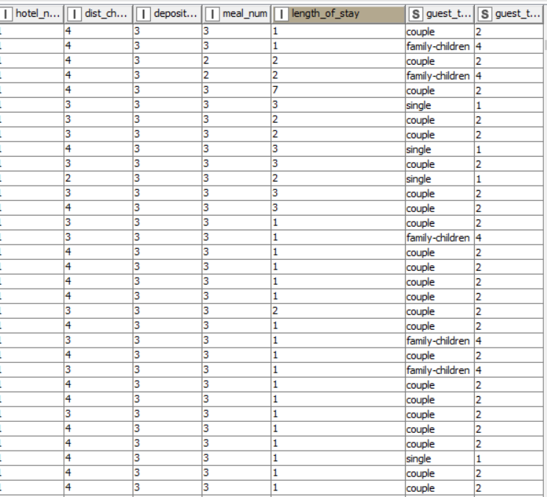

# DAVA – Hotel Booking Analytics – Clustering or Regression?

3. The option I have selected is: Option 2 (Regression)

a) Steps taken:

Partition node has been added to partition the data to 70% training dataset and 30% testing dataset. Node has been configured to use a random seed of 123456789 so that the sampling can be replicated.

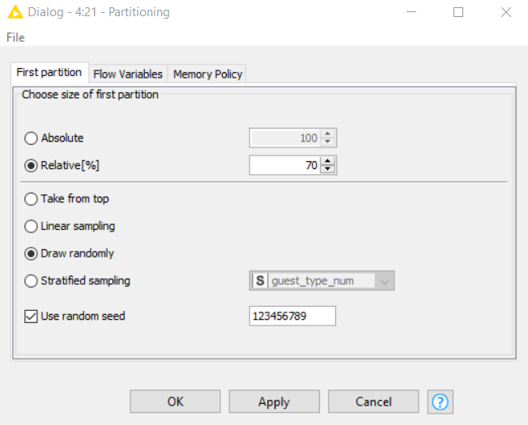

Linear regression node has been added after the dataset has been partitioned. The configuration goes by setting the total_of_special_requests as the target (dependable variable).

For the inputs (independent variables), all numeric features as been added.

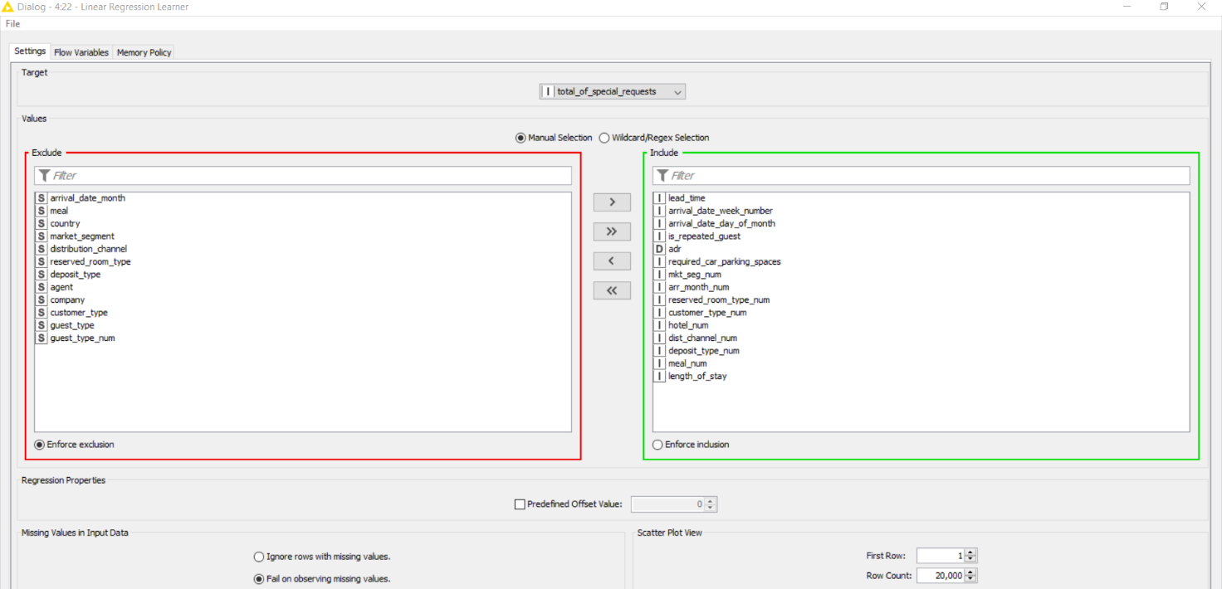

**Coefficients and Statistics**

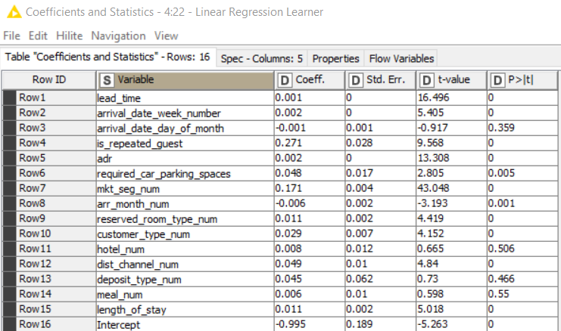

**Linear Regression Equation**

Predicted (Special Requests) = 0.001 * lead_time + 0.002 * arrival_date_week_number – 0.001 * arrival_date_date_of_month + 0.271 * is_repeated_guest + 0.002 * adr + 0.048 * required_car_parking_spaces + 0.171 *mkt_seg_num – 0.006 *arr_month_num+ 0.011 *reserved_room_type_num + 0.029 * customer_type_num + 0.008 * hotel_num + 0.049 * dist_channel_num + 0.045 * deposit_type_num + 0.006 *meal_num + 0.011 * length_of_stay - 0.995 **Intercept**

**Output Score**

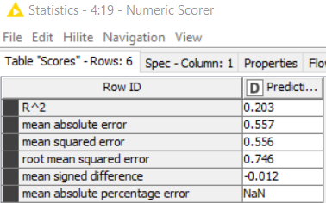

b) My Findings / Explanation:

**Useful Features**

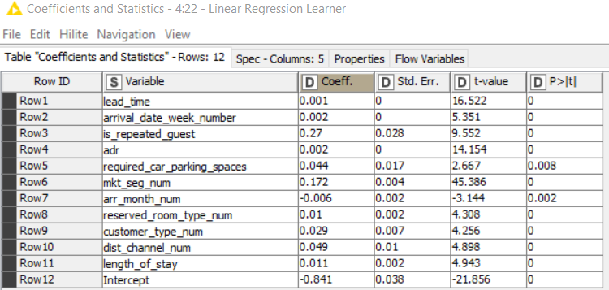

As seen in the linear regression learner node, lead_time, arrival_date_week_number, is_repeated_guest, adr, required_car_parking_spaces, mkt_seg_num, arr_month_num, reserved_room_type_num, customer_type_num, dist_channel_num, length_of_stay are all predictors that has a low p-value (< 0.05) which gives a meaningful addition to the regression model.

**Linear Regression Equation**

Predicted (Special Requests)= 0.001 * lead_time + 0.002 * arrival_date_week_number + 0.27 * is_repeated_guest + 0.002 * adr + 0.044 * required_car_parking_spaces + 0.172 *mkt_seg_num – 0.006 *arr_month_num+ 0.01 *reserved_room_type_num + 0.029 * customer_type_num + 0.049 * dist_channel_num + 0.011 * length_of_stay - 0.995 **Intercept**

**Output Score**

The output score still displays the same R Squared. This might imply that the amount of variance is high which finds it hard to identify the relationship between the variables. Also, this might suggest that the regression model is overfitting and the model isn't very effective at producing accurate predictions despite having predictors with p-value (<0.05).

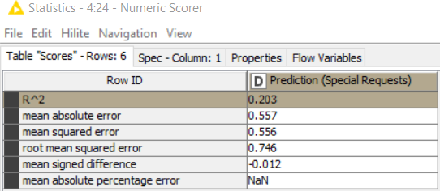

**Power Bi Findings**

The first scatterplot – Predicted vs Actual Special Requests

* Details: *Row ID*
* X-axis: *Prediction (total_of_special_requests)*
* Y-axis: *total_of_special_requests*

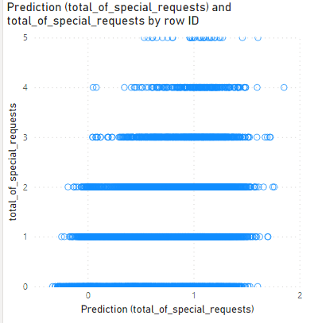

The model doesn’t have all the points forming a perfect diagonal line and doesn’t show any accuracy for the prediction on the total of special requests.

Residuals = Hotel_Bookings_Output [total_of_special_requests] - Hotel_Bookings_Output [Prediction(total_of_special_requests)]

The second scatterplot – Residual Plot

* Details: *Row ID*
* X-axis: *Prediction (total_of_special_requests)*
* 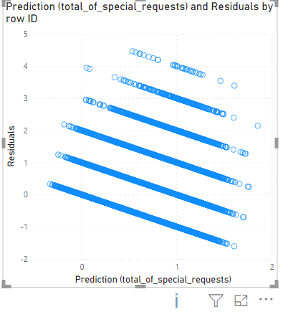Y-axis: *Residuals*

The residual plot for the model doesn’t have all the points forming a perfect horizontal line on 0 on the Y-axis as the model cannot generalize well due to overfitting.

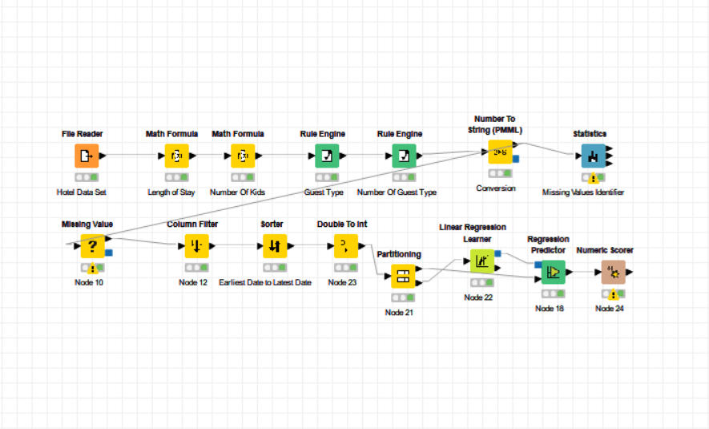Screenshot of my overall KNIME workflow is shown below.

|  |
| --- |
| SUBMISSION INSTRUCTIONS   * Save this file as “Assignment_Part2_[Your Class]_[Your Full Name]”, e.g. “***Assignment_Part2_Group 1_Peter Lam***” * Submit your report to PolyMall site > Assessment > Assignment >   Look for the appropriate link to submit your work. |

***** END OF ASSIGNMENT PART 2 *****